**Part I Env Setup**

1. JDK Version: 1.8
2. Developer Tools: Eclispe, VSCode
3. DB: Mariadb
4. Download and Install in your local PC

<https://downloads.mariadb.org/mariadb/10.5.6/#file_type=zip>

1. create db interview, connection username and password interview/interview
2. Run src/main/resources/initial.sql to create tables
3. Import Java Project to eclipse

**Part II Exam Requirement**

1. Create a new menu next to Index called “Contacts”
2. Under Contacts Page, List down all Contacts by backend pagination
3. In the List Tables, we can support delete or edit contact one by one
4. In the top of Contacts Page, add a Add Contact button to add new contact
5. In the top of Contacts Page, add a download button to generate contacts list report in xlsx format, sample report can reference Contacts_List_Report_DDMMYYYY.xls

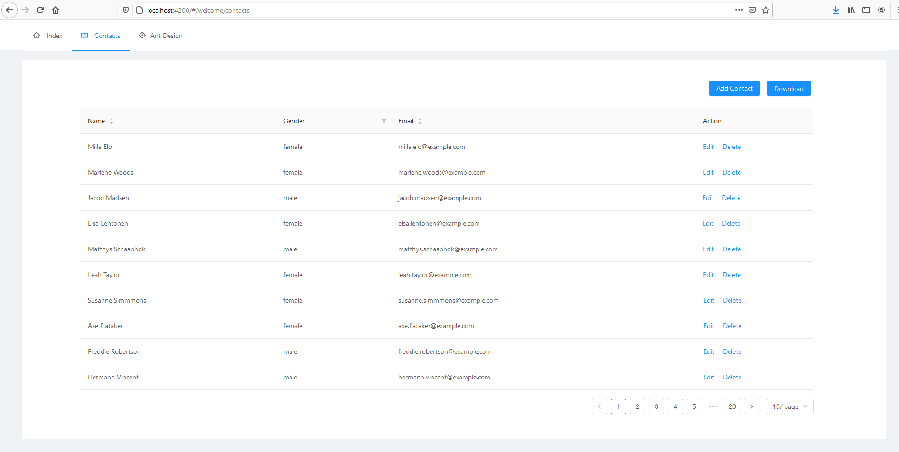

Note:

1. This is Spring Boot + Angular Project, for backend developer at least completed all APIs code, if can complete UI part is plus.
2. The code should sperate with three layers: Controller, Service, DAO. OR Mapping framework can be JDBCTemplate/MyBatis/Hibernate
3. API need follow RESTful style
4. At the key part, we need print logs for issue tracking
5. All the code must be formatted by eclipse
6. All API should work fine with Swagger UI
7. UI using Angular 7, the framework is ng-zorro, below is the online document.

<https://ng.ant.design/version/7.5.x/docs/introduce/en>

1. More details can check /epayslip-interview/README.md